32.27: a) The node-antinode distance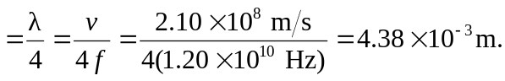
b) The distance between the electric and magnetic antinodes is one-quarter of a wavelength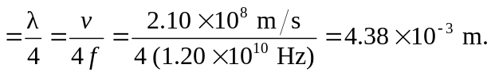
c) The distance between the electric and magnetic nodes is also one-quarter of a wavelength
